

DEPARTMENT OF COMPUTER SCIENCE & ENGINEERING

**SOUTHEAST UNIVERSITY**

**Internship Report**

**On**

**Frontend Developer**

A dissertation was submitted to Southeast University for the purpose of

the requirements for the degree of B. Sc. in Computer Science & Engineering.

**Submitted By**

Mehedi Hasan Ridoy

Id:2018200000045

Batch: 50th

**Supervised By**

Nahin Kumar Dey

Lecturer

Department of CSE,

Southeast University

Copyright©2022

**Letter of Transmittal**

October 27, 2022

The Chairman,

Department of Computer Science & Engineering,

Southeast University,

Banani, Dhaka-1213.

Through: Lecturer, Nahin Kumar Dey.

Subject: Submission of Internship Report.

Dear Sir,

It is an honor and a joy for me to present my internship report titled named by "Frontend Developer," which was created as a requirement of my degree. It's a huge opportunity for me to gather a lot of information and understand the subject matter properly. I thought the study to be fascinating, beneficial, and informative, and I did my best to create an effective and credible report.

I truly hope that not only will my analysis help to provide a clear picture of the overall state of "Frontend Developer at URLBD Solutions’’ but that you will also discover that the time and attention I put into this research was well worth it. All of your questions are welcome, and I am happy to answer them.

Thank you.

Sincerely, Supervisor,

Mehedi Hasan Ridoy Nahin Kumar Dey

Id: 2018200000045 Lecturer

Batch: 50th Department Of CSE

**Certificate**

This is to certify that the report titled “Frontend Developer “has been submitted by Mehedi Hasan Ridoy in partial fulfillment of the requirements for the award of a degree (BSc. in CSE) in the Department of Computer Science and Engineering of Southeast University. This is a record analysis carried out by Mehedi Hasan Ridoy, ID: 2018200000045 under my supervision. No part of the internship report has been submitted for any other degree and the performance of the students has been accepted as satisfactory.

Supervisor Co-Supervisor

Nahin Kumar Dey Shamsuddin Muttaki

Lecturer Executive Director,

Department of CSE URLBD Solutions.

Southeast University

**Abstract**

The "front-end languages" are browser-based. My browser will obtain at least an HTML file from the website after entering an address into the address bar at the top and pressing the enter or return key. That file probably instructs the browser to ask for both CSS and JavaScript files.

The web page's structure (HTML), appearance (CSS), and functionality (JavaScript) are all determined by each of these languages, each of which serves a unique but crucial purpose. Also bear in mind that my browser handles converting these files into a usable web page.

This internship's main purpose is learning and developing a website's front end. Numerous programming languages are used to create web-based applications. Some of them are exclusively utilized for front-end and back-end software design. An illustration would be HTML3, HTML4, HTML5, CSS, Bootstrap, JavaScript, etc. Additionally, WordPress is utilized to create a website's front end.

I am creating their entry point to my page or product; therefore, I will need to be very aware of who my user is and how they will engage with it on the front end. In the future, this could entail learning a lot about responsive development and other topics like accessibility, but for now, I need to stock up on resources and learn the basics of front-end programming languages.

This report goes into great depth on the front end developing knowledge and experience that were acquired throughout this internship.

**Acknowledgment**

The success and result of this internship require a lot of guidance and endorsement from many people and I am fortunate to get all of these throughout my entire internship project. I was able to accomplish this project only with such assistance and supervision. I will never forget to thank them.

First and foremost, I thank Almighty Allah for assisting me in successfully completing my report. I am grateful to URLBD Solutions for allowing me to work as an intern with them. Mr. Nahin Kumar Dey, Lecturer, at Southeast University, deserves my gratitude for being a helpful supervisor and for providing me with proper guidance in completing my internship report, which is a requirement for my Undergraduate program.

I respect and thank Mr. Shamsuddin Muttaki who allowed me to work on a frontend project at URLBD Solutions and gave me all the support and guidance that motivated me to complete the project properly. Despite being busy dealing with corporate matters. I am very grateful to him for such admonition.

My thanks to my family member for supporting me mentally and financially. I will never forget their support, guidance, encouragement, and more until my project is accomplished.

In addition, I would like to express our heartfelt gratitude to all the people for their support and guidance.

***Content***

**Title Page**

**Abstract**………………………………………………………………………………… i

**Acknowledgment**………………………………………………………………………. ii

**List of Figure**……………………………………………………………………..……. iv

**1. Introduction**…………………………………………………………………………. 1

1.1 Introduction………………………………………………………….…………...... 1

1.2 Introduction to the company………………………………………………………. 1

1.2.1 Product of URLBD Solutions…………………………………………………… 2

1.3 Objective of the Internship………………………………………………………… 3

1.4 Scope and Methodology…………………………………………………………… 3

1.4.1 Scope…………………………………………………………………………...… 3

1.4.2 Methodology…………………………………………..………………………… 4

**2. Literature Review**………………………………………..……………………………5

2.1 Frontend Web Development………………………..…………………………...… 5

**3. Details of Internship**………………………………………………………………… 7

3.1 Daily Task and Activity…………………………………………………………… 7

3.2 Project Task and Activity……………………………………………………………7

**4. Key Result/ Key Learning**…………………………………………………………….16

**5. Limitations and Recommendations**…………………………………………………...17

**6. Conclusions**……………………………………………………………………………..18

**Bibliography**………………………………………………………………………………18

**Appendix A**………………………………………………………………………………. 18

**List Of Figure**

|  |  |  |
| --- | --- | --- |
| **Figure Number** | **Figure Name** | **Page** |
| Fig 1 | Product and Services of URLBD Solutions | 2 |
| Fig 2 | Report Methodology | 4 |
| Fig 3 | Home Page of Dubai Agro | 7 |
| Fig 4 | Product Category | 8 |
| Fig 5 | Product List | 8 |
| Fig 6 | Featured Product | 9 |
| Fig 7 | About Page of Dubai Agro | 9 |
| Fig 8 | Blog page of Dubai Agro | 10 |
| Fig 9 | Contact Page of Dubai Agro | 10 |
| Fig 10 | Used Plugin | 11 |
| Fig 11 | Home of CAFERT | 12 |
| Fig 12 | Breakfast Menu | 12 |
| Fig 13 | About CAFERT | 13 |
| Fig 14 | Blog Page | 13 |
| Fig 15 | Contact Page | 14 |
| Fig 16 | Login- Form | 14 |

**Chapter-1**

**Introduction**

**1.1 Introduction**

Front-end web development is the process of converting data to a graphical interface so that the customer may view and interact with it through computerized collaboration using HTML, CSS, WordPress, and other languages. Front-end web development, also known as customer-side development, is the process of writing HTML, CSS, JavaScript, and WordPress for a website or Web application so that a user can access it and interact with it directly. The challenge with front-end enhancement is that the tools and techniques used to create the front finish of a site vary constantly, therefore the engineer must always be aware of how the industry is developing.

* 1. **Introduction To the Company**

Blessed with 11 years of positive change and driven by collaboration, the present acknowledgment framework is Data Innovation, Programming, and Incorporated Web-based business Advancement Organization the nearness in Bangladesh (Dhaka).

URLBD Solutions is an expert Web-based business and programming improvement organization in Bangladesh giving a scope of reasonable custom web composition, and economical web-based business web architecture administrations to customers over the world.

URLBD Solutions started as a local company and soon they converted into a global one. They developed many websites and digital content for several business enterprises in having a strong online presence. They help startups & companies to create great websites & Brand designs.

They started their company in 2011. They aim to ensure the prosperity of your company, they believe that a good delivery is only possible due to their listening to you and that is what the way they work at.

* + 1. **Products of URLBD Solutions**

**1.2.1.1 Hosting**

* Shared Hosting
* WordPress Hosting
* Reseller Hosting
* VPS Hosting
* Dedicated Server Hosting

**1.2.1.2 Services**

* Make a website
* E-commerce website
* Logo Design
* Website Security
* Business Email

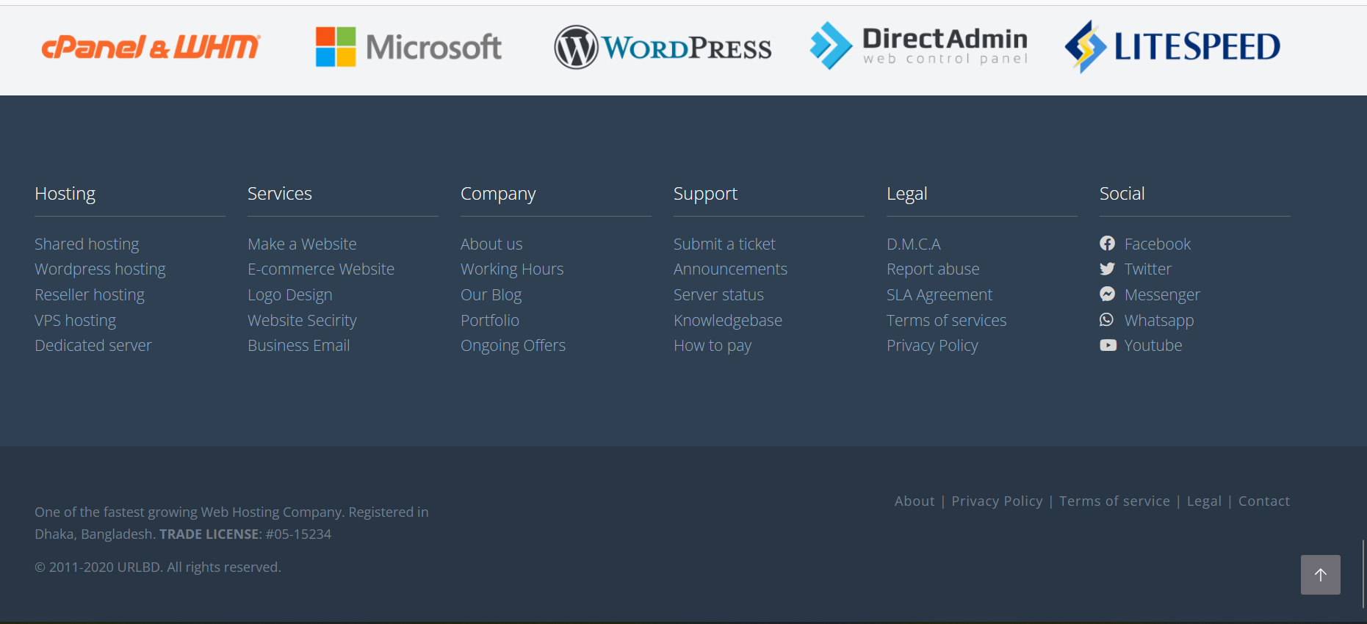Fig 1: Product and Services of URLBD Solutions

**1.3 Objective of the Internship**

* Learning the related dialects in subtleties.
* Completing the undertaking in time.
* Gaining Consumer loyalties with expert work.
* Experience advanced patterns and necessities of website composition.
* Recognize and unravel configuration issues.

**1.4 Scope And Methodology**

**1.4.1 Scope**

There is a great deal of space to improve the structure of the site. This work is only the fundamental arrangement of the undertaking. We can include some more components later on if necessary. Future work can characterize more use cases for various purposes like international payment gateway and a lot of things of interest for Purchasers. The other group has officially done the backend part of the task. They likewise will do some improvement is fundamental.

* + 1. **Methodology**

A picture says a lot about anything, so it is better to present the whole project simply with the help of a figure for a better understanding of the project. The project report consists of 6 chapters. The outline of this chapter with a summary is discussed below through demographic representation:

|  |
| --- |
| **Chapter 1: Introduction** (Presentation of the company, Objective of the internship, scope, and methodology) |

|  |
| --- |
| **Chapter 2: Literature Review**() |

|  |
| --- |
| **Chapter 3: Details of Internship**() |

|  |
| --- |
| **Chapter 4: Key Result/ Key Learnings** |

|  |
| --- |
| **Chapter 5: Limitations and Recommendations** |

|  |
| --- |
| **Chapter 6: Conclusion** |

Fig 2: Report Methodology

**Chapter 2**

**Literature Review**

**2.1 Frontend Web Development**

In my study, I have learned from Frontend design by using WordPress HTML, CSS, and JavaScript. These tools are essential for front-end design as a beginner developer.

**2.1.1 WordPress**

WordPress started in 2003 when Mike Little and Matt Mullenweg created a fork of b2/cafelog. The need for an elegant, well-architected personal publishing system was clear even then. Today, WordPress is built on PHP and MySQL, and licensed under GPLv2. It is also the platform of choice for over 43% of all sites across the web.

The WordPress open source project has evolved in progressive ways over time — supported by skilled, enthusiastic developers, designers, scientists, bloggers, and more. WordPress provides the opportunity for anyone to create and share, from handcrafted personal anecdotes to world-changing movements. People with limited tech experience can use it “out of the box”, and more tech-savvy folks can customize it in remarkable ways.

**2.1.2 Hypertext Markup Language**

HTML was created by Tim Berners-Lee in 1987. HTML is the standard markup language for making Site pages. HTML represents Hypertext Markup Language. It depicts the structure of Site pages utilizing markup. HTML components are the structure blocks of HTML pages. Its components are spoken to by labels. Its labels mark bits of substance, for example, "heading", "section", "table, etc. Programs don't show the HTML labels yet use them to render the substance of the page.

**2.1.3 Cascading Style Sheet (CSS)**

Hakon Wium Falsehood is the dad of CSS. Untruth proposed the idea of Falling Templates (CSS) in 1994 while with the W3C. CSS represents Falling Templates. CSS portrays how HTML components are to be shown on the screen, on paper, or in other media. It spares a great deal of work. It can control the format of numerous website pages at the same time. Outer templates are put away in CSS documents.

**2.1.4 Bootstrap**

Bootstrap was created by Mark Otto on August 19, 2011. Bootstrap is a free and open-source CSS framework directed at responsive, mobile-first front-end web development. It contains HTML, CSS, and JavaScript-based design templates for typography, forms, buttons, navigation, and other interface components.

**2.1.5 JavaScript**

JavaScript, often abbreviated as JS, is a programming language that is one of the core technologies of the World Wide Web, alongside HTML and CSS. As of 2022, 98% of websites use JavaScript on the client side for webpage behavior, often incorporating third-party libraries [4].

**Chapter 3**

**Details of Internship**

**3.1 Daily Tasks and Activities**

URLBD Solutions is extraordinary compared to other organizations in our nation. Here I work as an Internee for 120 Days. Here I learn and practice front-end structure for Web composition and creation. As an apprentice engineer, I Practice in this organization WordPress, HTML, CSS, and JavaScript. HTML and CSS are most significant for front-end web architecture. I consistently work in this IT Organization from 08:00 am to 2:00 pm; seven days. I work there in a group. My colleague is so useful.

**3.2 Project Task and Activities**

In URLBD Solutions I work on the front End Plan of Web architecture as a tenderfoot designer. Where I Utilized WordPress, HTML, and CSS for the front-end plan. URLBD Solutions get worked for a Customer Dubai Agro. There I doled out as Front-End Fashioner. I utilized for frontend plan with WordPress. Another single-page Project was done for a restaurant which is done in HTML, CSS, Bootstrap, and JavaScript. Also, a login page has been designed using HTML, and CSS-Tailwind.

**3.2.1 Dubai Agro**

**3.2.1.1 Home page**

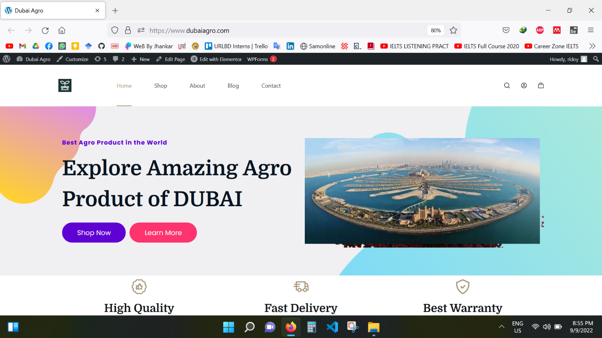

Fig 3: Home Page of Dubai Agro

**3.2.1.2 Product Catagory**

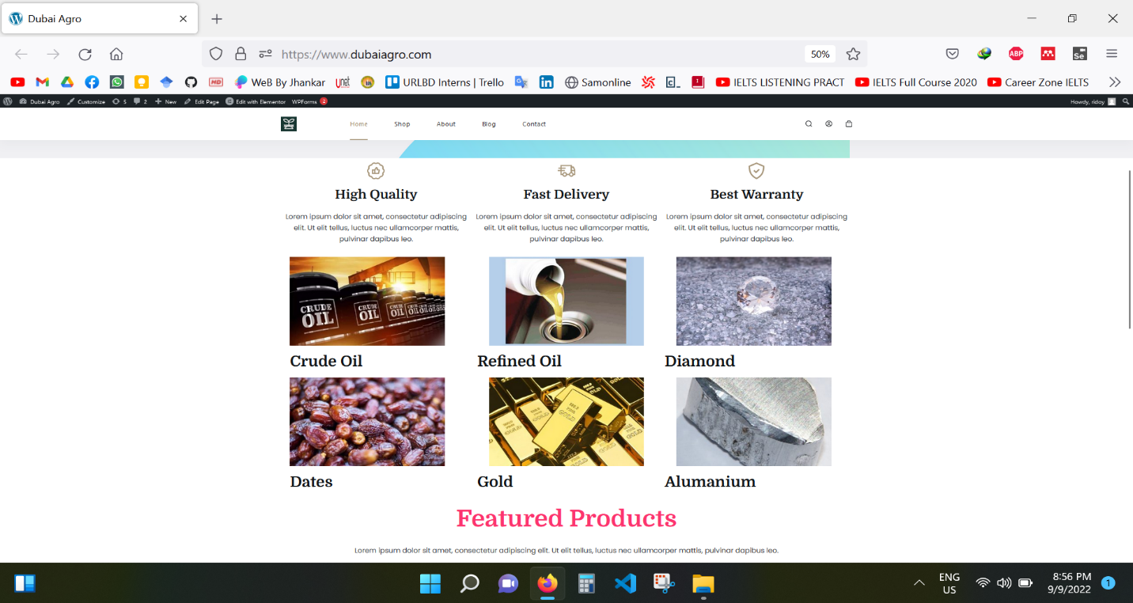

Fig 4: Product Catagory

**3.2.1.3 Product List**

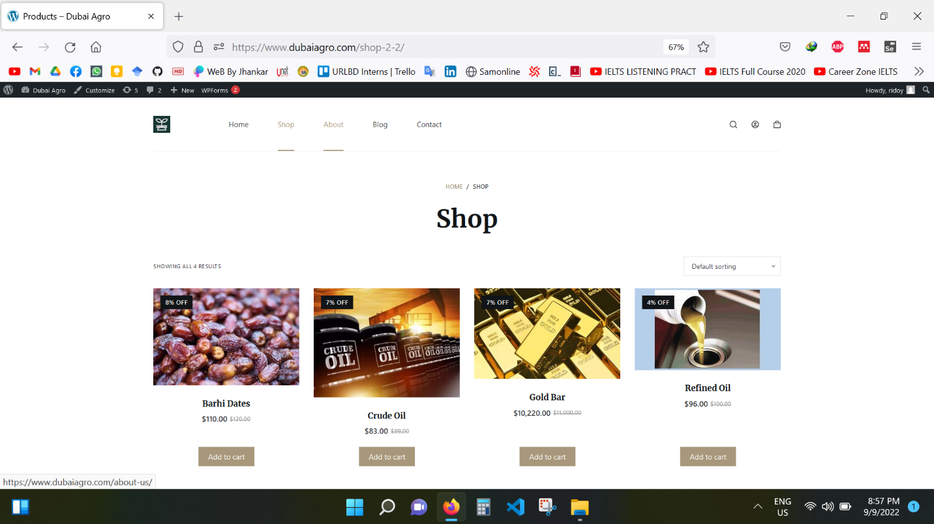

Fig 5: Product List

**3.2.1.4 Featured Product**

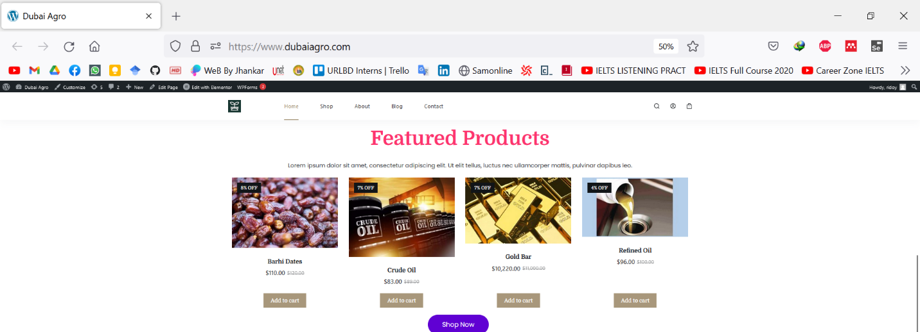

Fig 6: Featured Product

**3.2.1.5 About Dubai Agro**

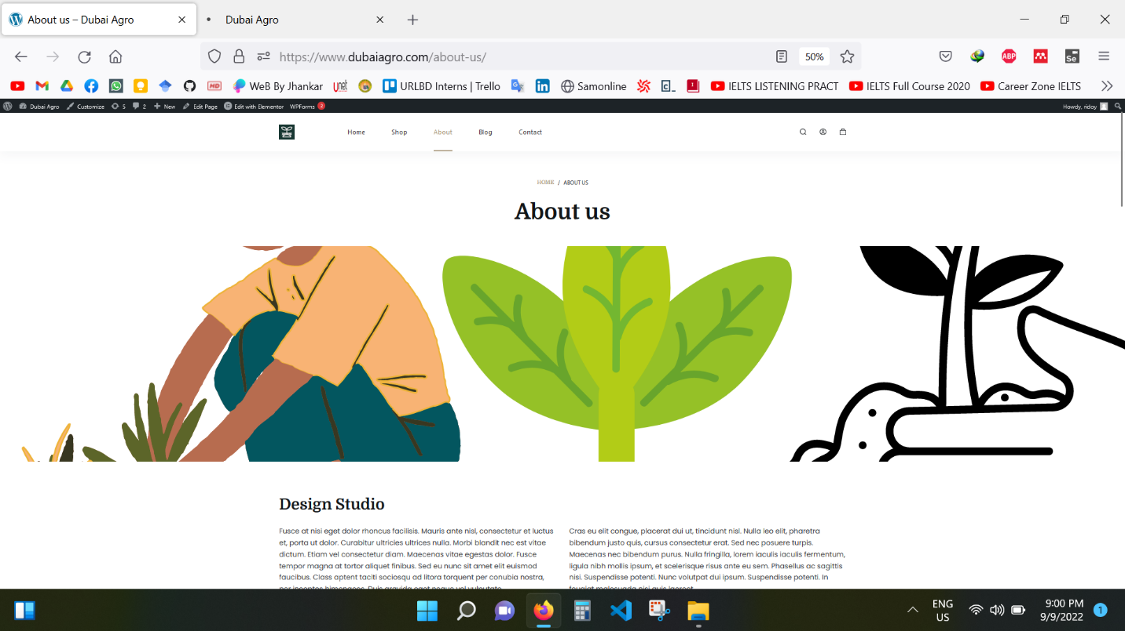

Fig 7: About Page of Dubai Agro

**3.2.1.6 Blog of Dubai Agro**

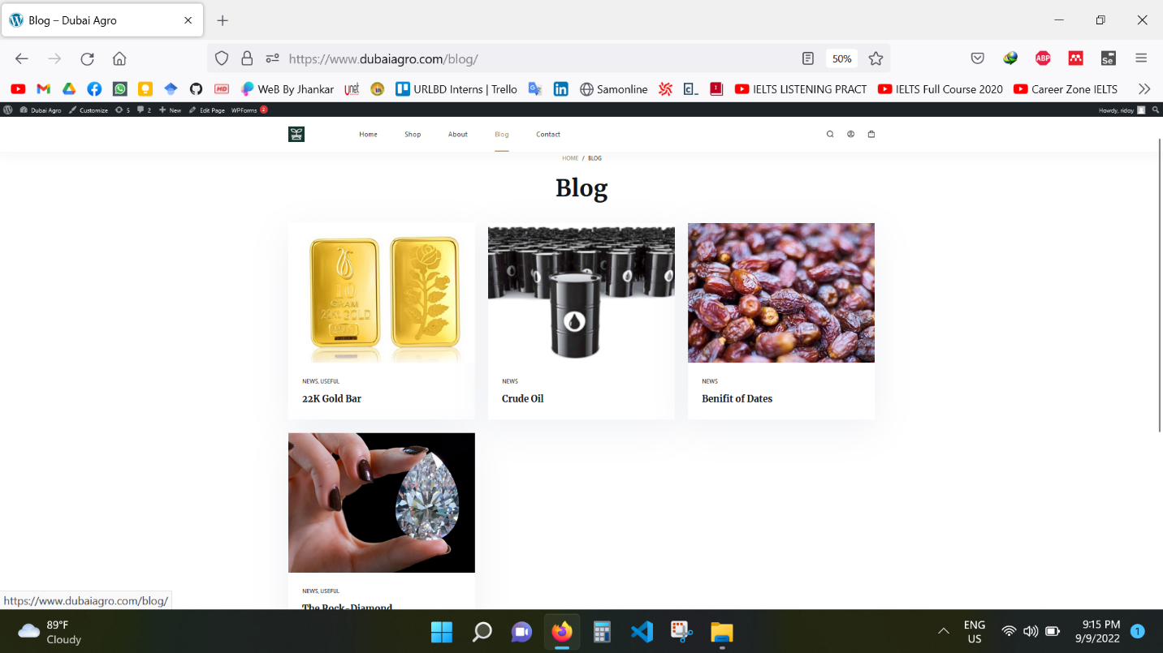

Fig 8: Blog Page of Dubai Agro

**3.2.1.7 Contacts of Dubai Agro**

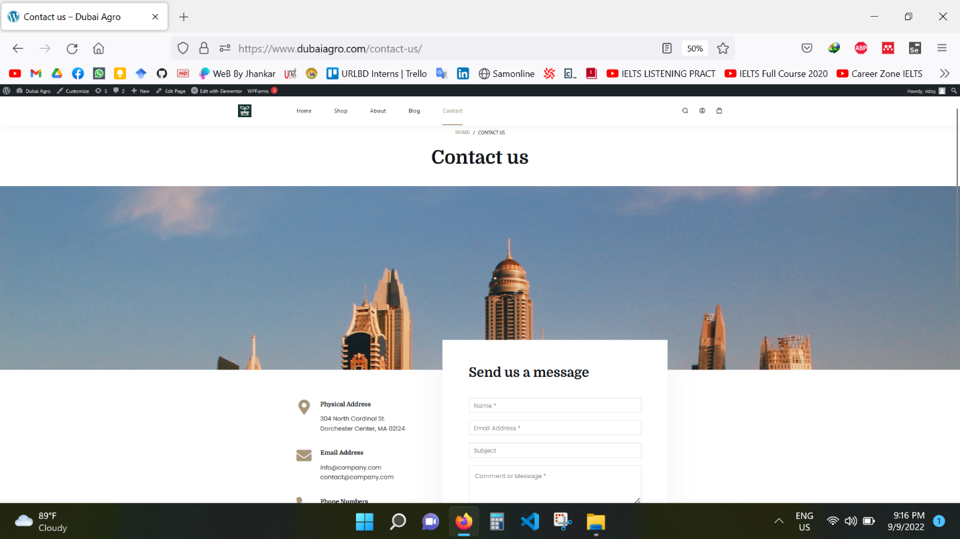

Fig 9: Contact Page of Dubai Agro

**3.2.1.8 Used Plugin**

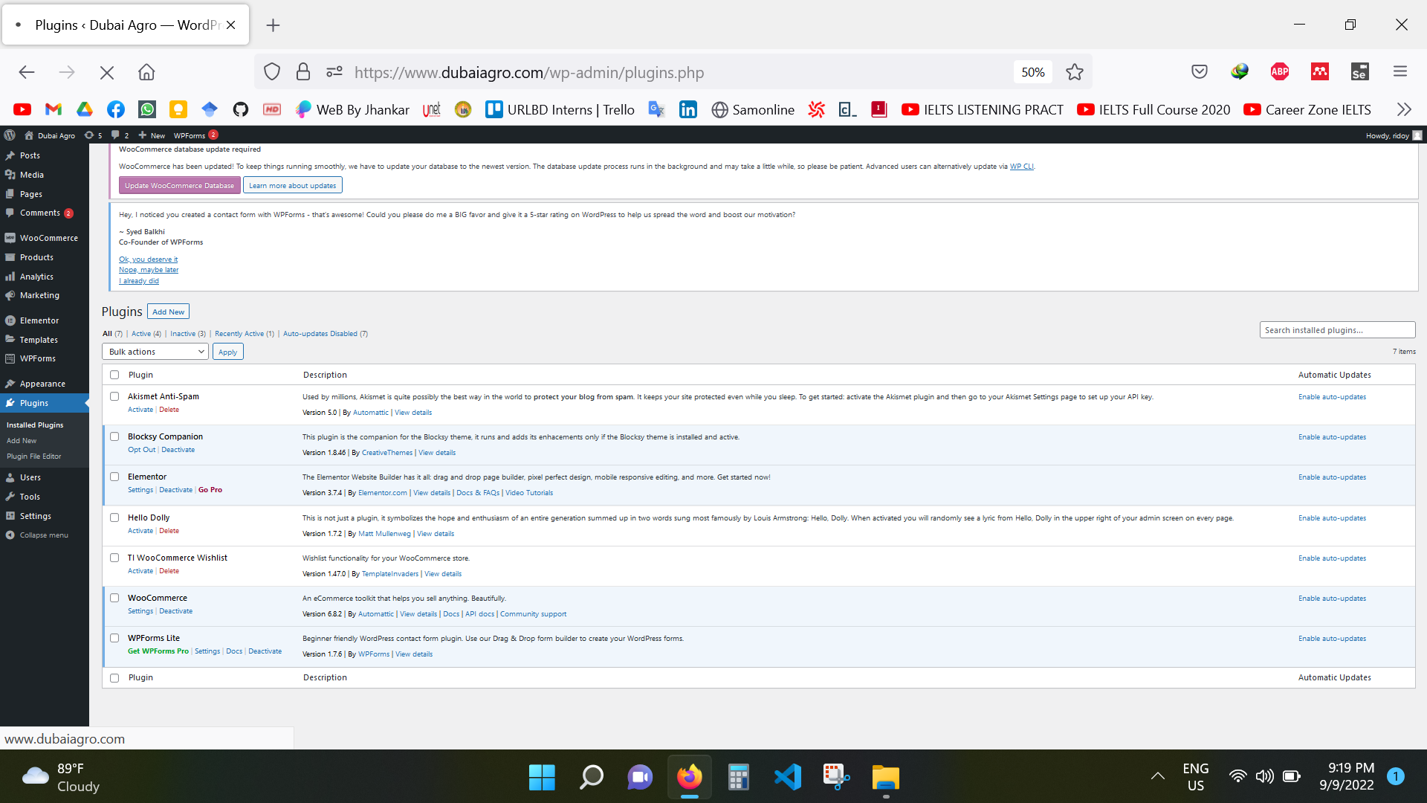

Fig 10: Used Plugin

**3.3 CAFERT**

**3.3.1 Home Page**

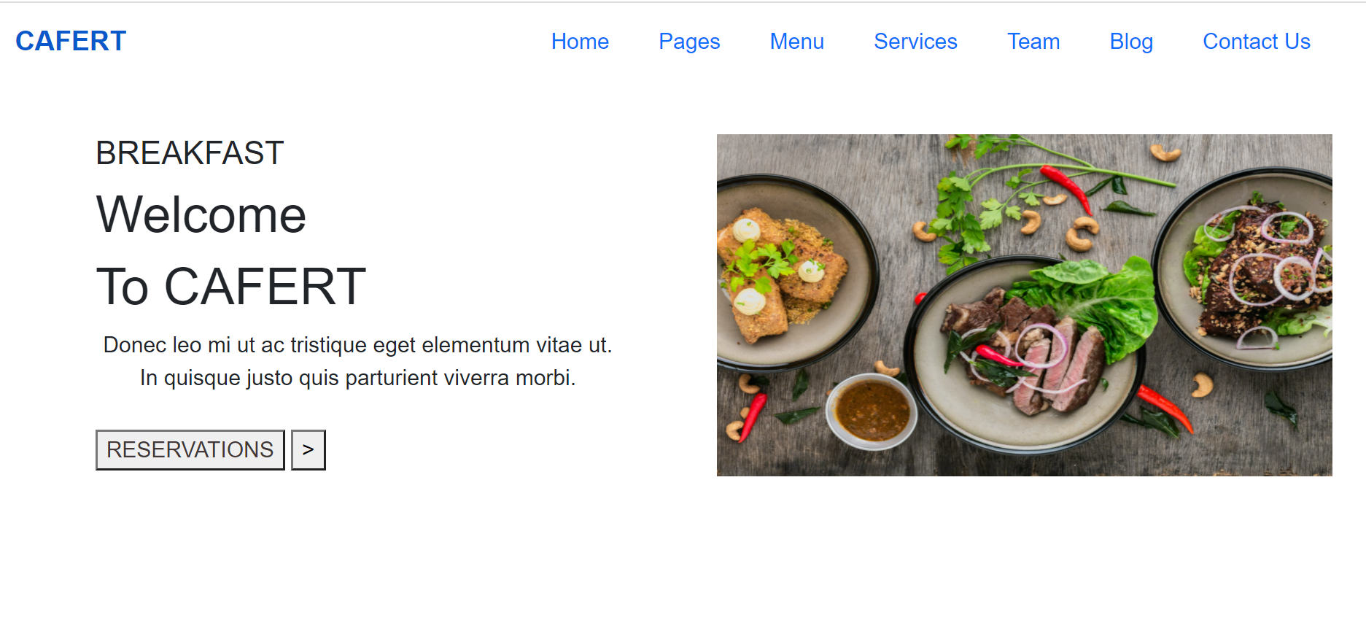

Fig 11: Home of CAFERT

**3.3.2 Breakfast Menu**

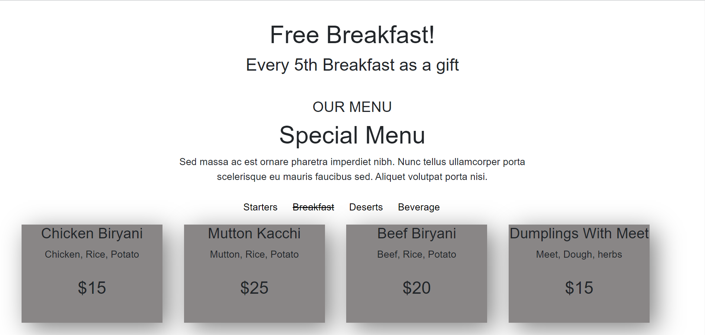

Fig 12: Breakfast Menu

**3.3.3 About Us**

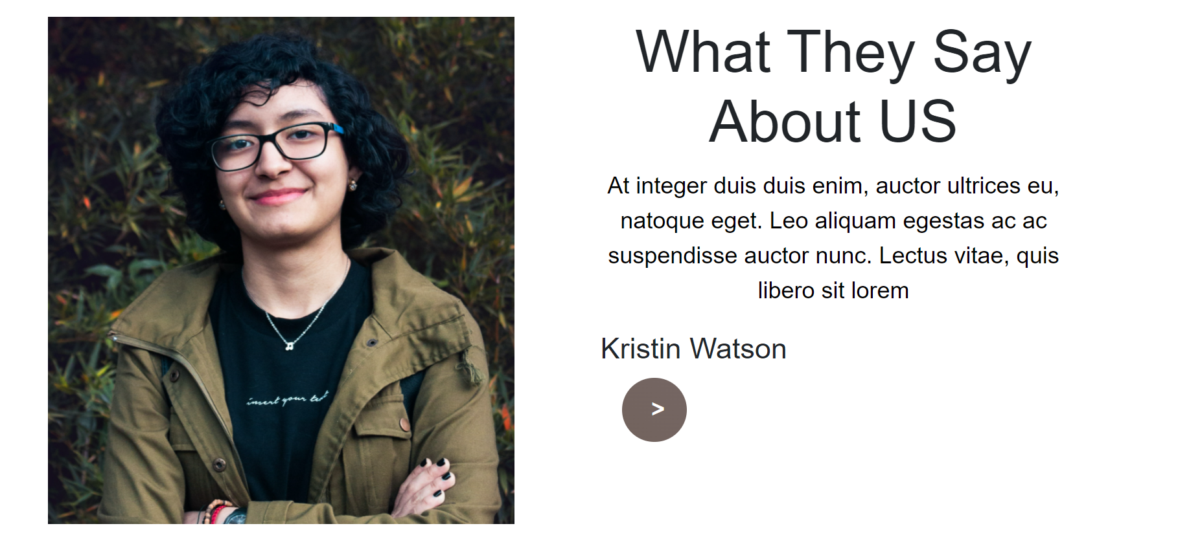

Fig 13: About CAFERT

**3.3.4 Blog Page**

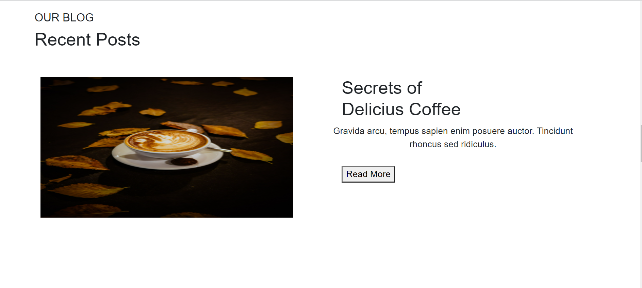

Fig 14: Blog Page

**3.3.5 Contact Page**

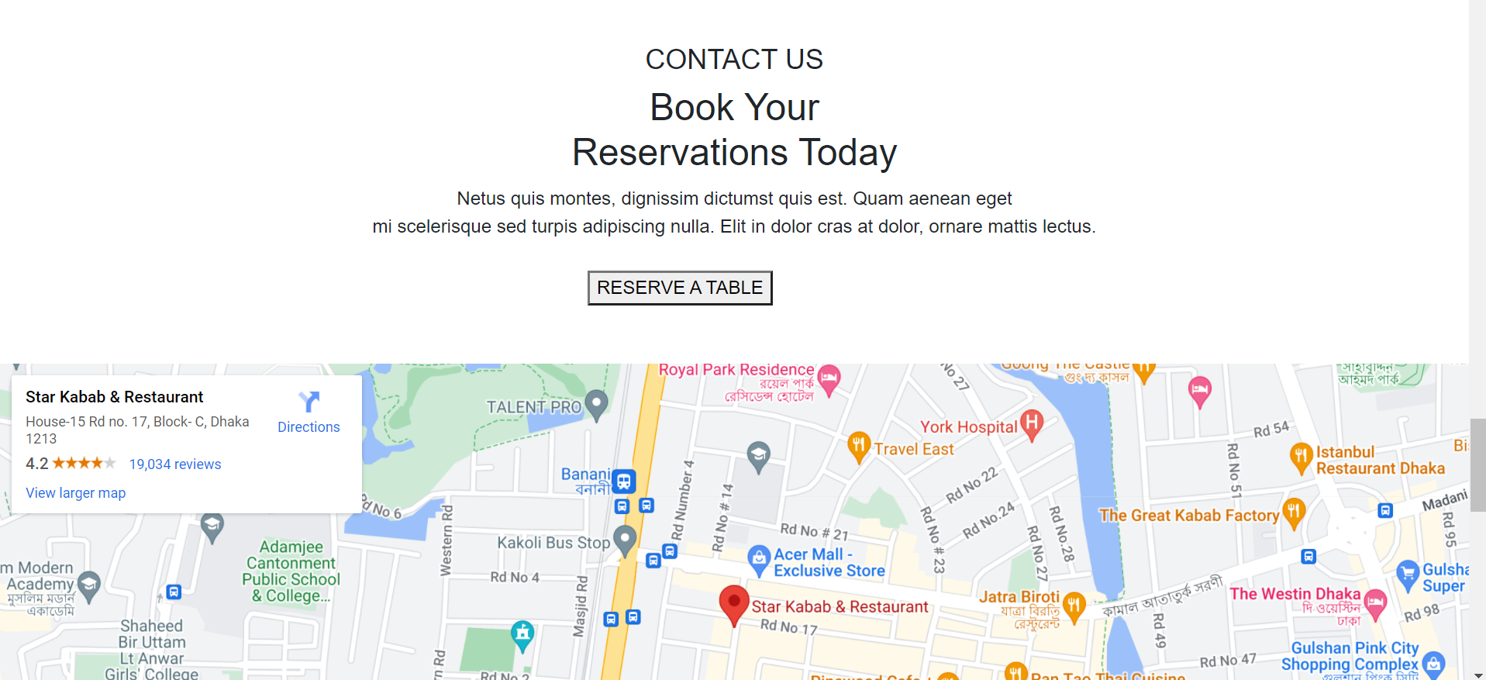

Fig 15: Contact Page

**3.4 Login Form of a School**

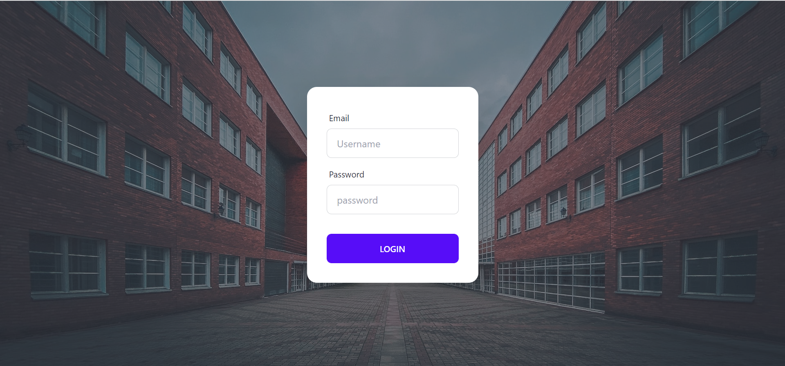

Fig 16: Login-Form

**3.5 Challenges**

The amount of studying I had to do when I first started as a front-end web designer was enormous. The documentation for the code was limited. I had to learn most of the time on my own back then because I rarely had a mentor to assist me through the learning process. In addition, I received a lot of challenging assignments with a tight schedule.

One of my seniors shared a neat trick that she often used in her day-to-day tasks. It turns out that she heavily relied on a "search in catalog" tool to understand a lot of the coding. From that point on, I learned how to combine that method with Google search. After a focused search, a ton of research, and a ton of testing, I became accustomed to quickly becoming familiar with a codebase on a variety of programming languages.

At the moment, I typically share my experiences with the new enrollment experts. Even if the situation we are in now isn't as dire as it once was, others can learn from my past mistakes.

**Chapter 4**

**Key Learnings**

**4.1 Learning**

My goal was to create the front end of the website project offered by URLD Solutions. Using WordPress, HTML, CSS, JavaScript. I have taken all essential precautions and am knowledgeable on these topics. My schooling prepared me well for the professional content of the temporary position. While positioning the site's content and doing the CSS padding, I encountered several challenges. I've learned how to work proficiently after work.

**Chapter 5**

**Limitations and Recommendations**

**5.1 Limitations**

Evaluation of end-user needs and design optimization in response to those requirements is the largest difficulty in front-end design. The requirements of end users vary greatly. When developing the graphics for a web page, designers work with HTML, JavaScript, CSS, and Flash. Front-end designers encounter a variety of issues.

**5.2 Recommendations**

URLBD Solutions is an ambitious Company in the IT sector. They provide shared hosting, WordPress hosting, and reseller hosting. They make websites, E-commerce websites. They provide Website security. As a result, URLBD Solutions provide its service since 2011 locally and now they serve their service globally. They should provide more internship opportunities to final-year students so that students can gain proper ideas and experience from them.

**Chapter-6**

**Conclusions**

**6.1 Conclusion**

In a nutshell, this internship has been an excellent and rewarding experience. I can conclude that there has been a lot I’ve learned from my work at URLBD Solutions. Needless to say, the technical aspects of the work I’ve done are not flawless and could be improved provided enough time.

As someone with no prior experience in WordPress, Bootstrap, or Tailwind whatsoever I believe my time spent in research and discovering new languages was well worth it and contributed to finding an acceptable solution to an important aspect of web design and development. Two main things that I’ve learned are the importance of our time-management skills and self-motivation. This learning and developing process will help me in my future and my career life.

**Bibliography**

* W3 schools
* StackOverflow
* Several youtube channels
* Bootstrap documentation
* Tailwind Documentation
* Google

**Appendix A- Table of Weekly Task**

|  |  |  |
| --- | --- | --- |
| Week | Tasks | Completed Module |
| 1 | Study About WordPress | Finished study |
| 2 | Study About Dubai Agro | Finished Study |
| 3 | Work On Edit and Design Dubai Agro | update on the progress |
| 4 | Work with Dubai Agro | Finished design |
| 5 | Study About Security and SEO | Finished Study |
| 6 | Work on Security and SEO | Finished the task |
| 7 | Study About HTML, CSS, Bootstrap, Tailwind | Finished Study |
| 8 | Make a login form using HTML, Tailwind | Finished the task |
| 9 | Work on a single-page restaurant website | Update the progress |
| 10 | Fixing the error in design by developing the design | Finished |